Step 1 Log into your student portal.

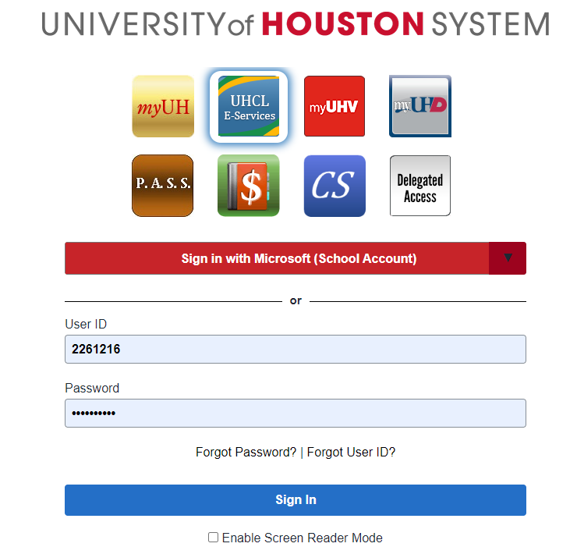

Step 2 Click on the “Finance” tab on your student homepage.

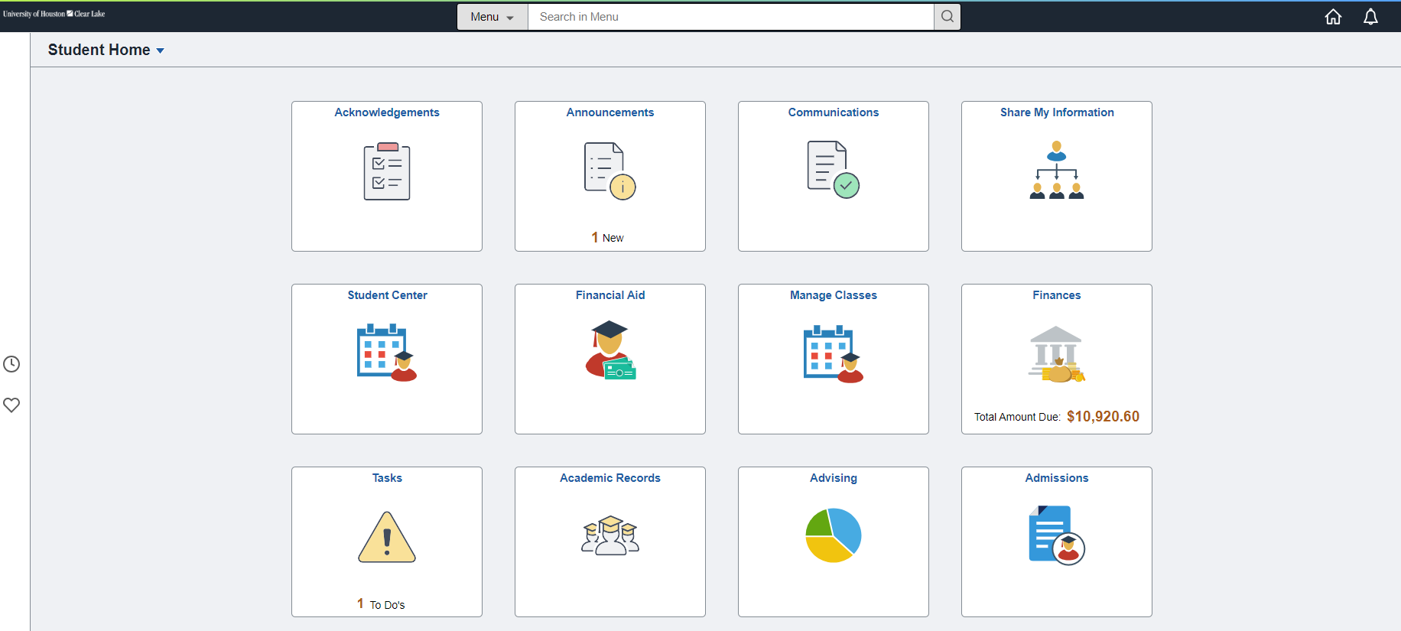

Step 3 The Student Financials Collections page will load. From here click the “Payment Plan” hyperlink on the lefthand side of the screen.
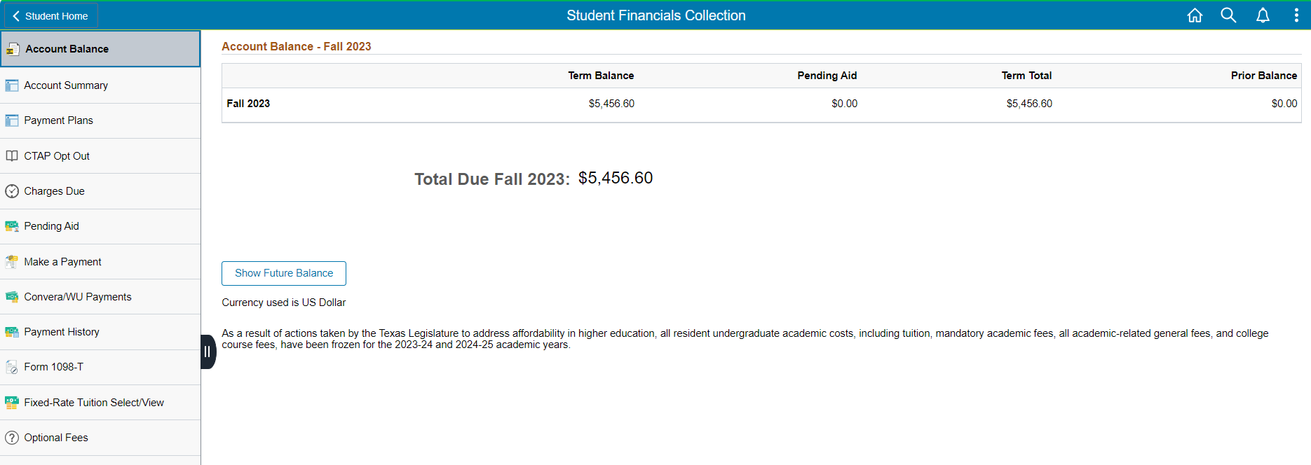

Step 4 Select the Installment Plan.
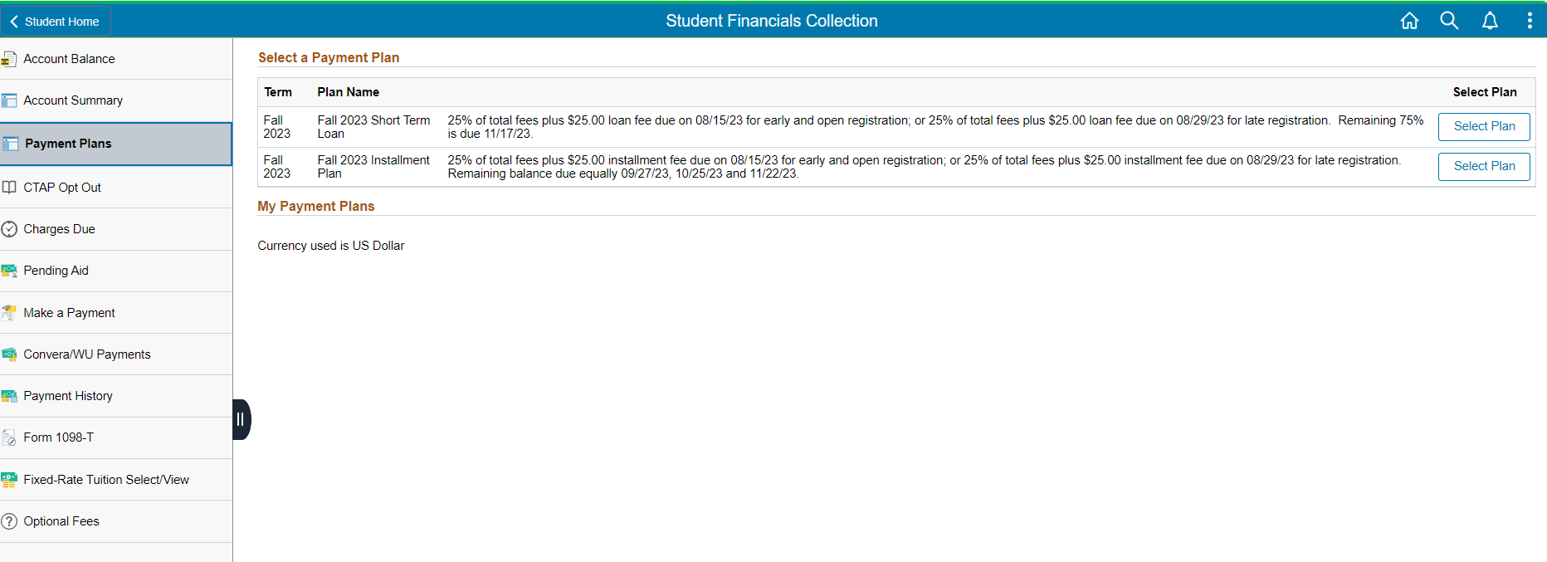
Step 5 Review this page with the Estimated Payment Plan Charges and click, Continue.
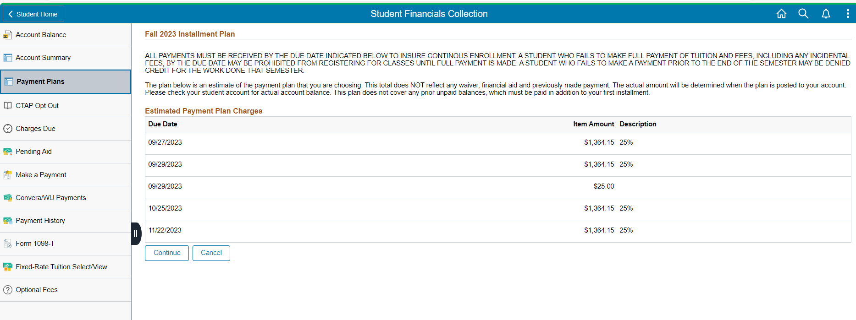
Step 6 Read this page in its entirety and if you agree, click “Accept Plan.”
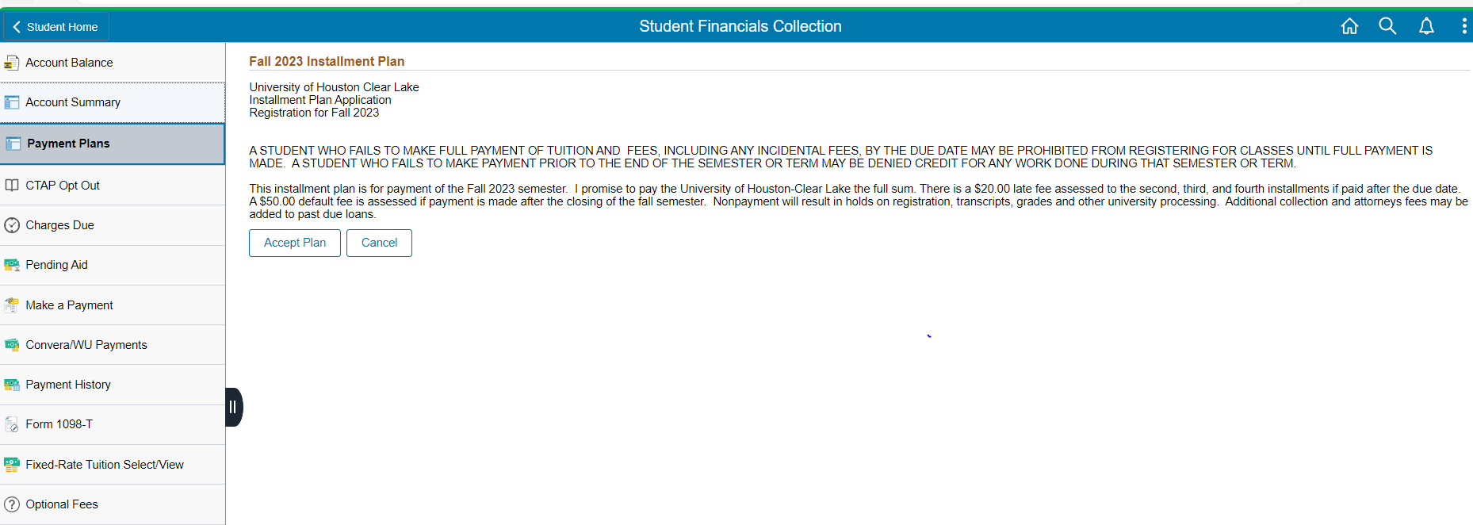

Step 7 The installment plan will load under the “My Payment Plans” heading. Click the double arrows.
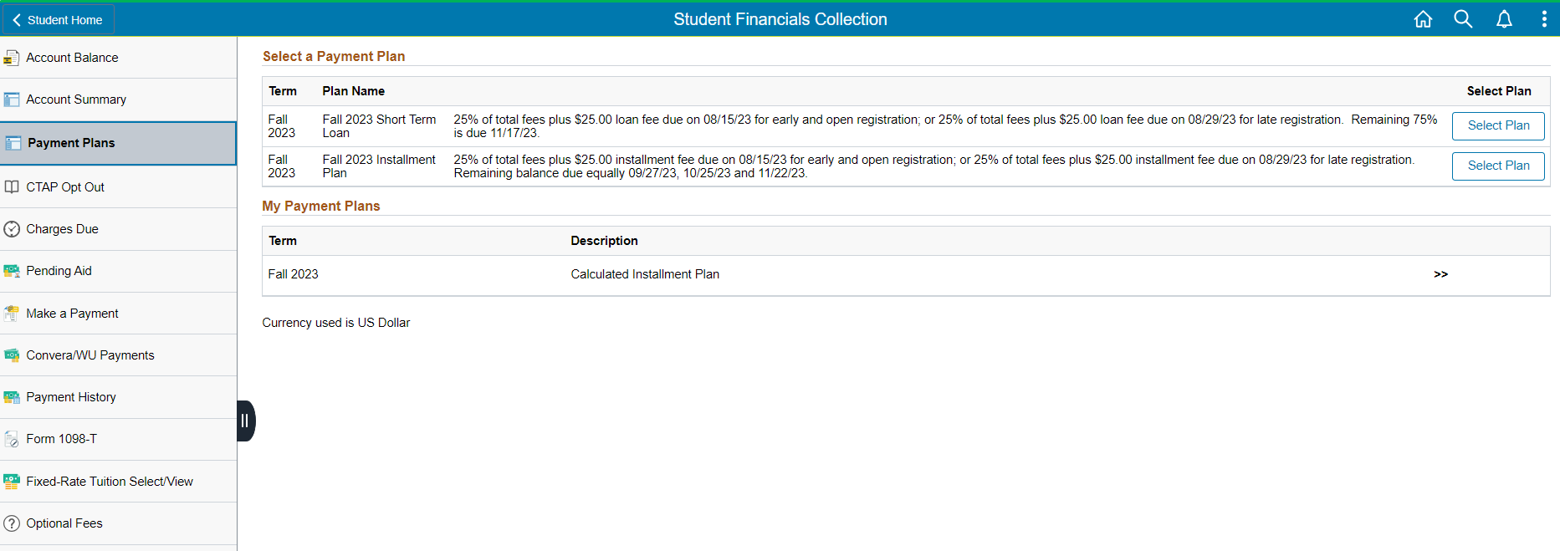

Step 8 The installment dates and amounts will appear. You are enrolled in a payment plan.
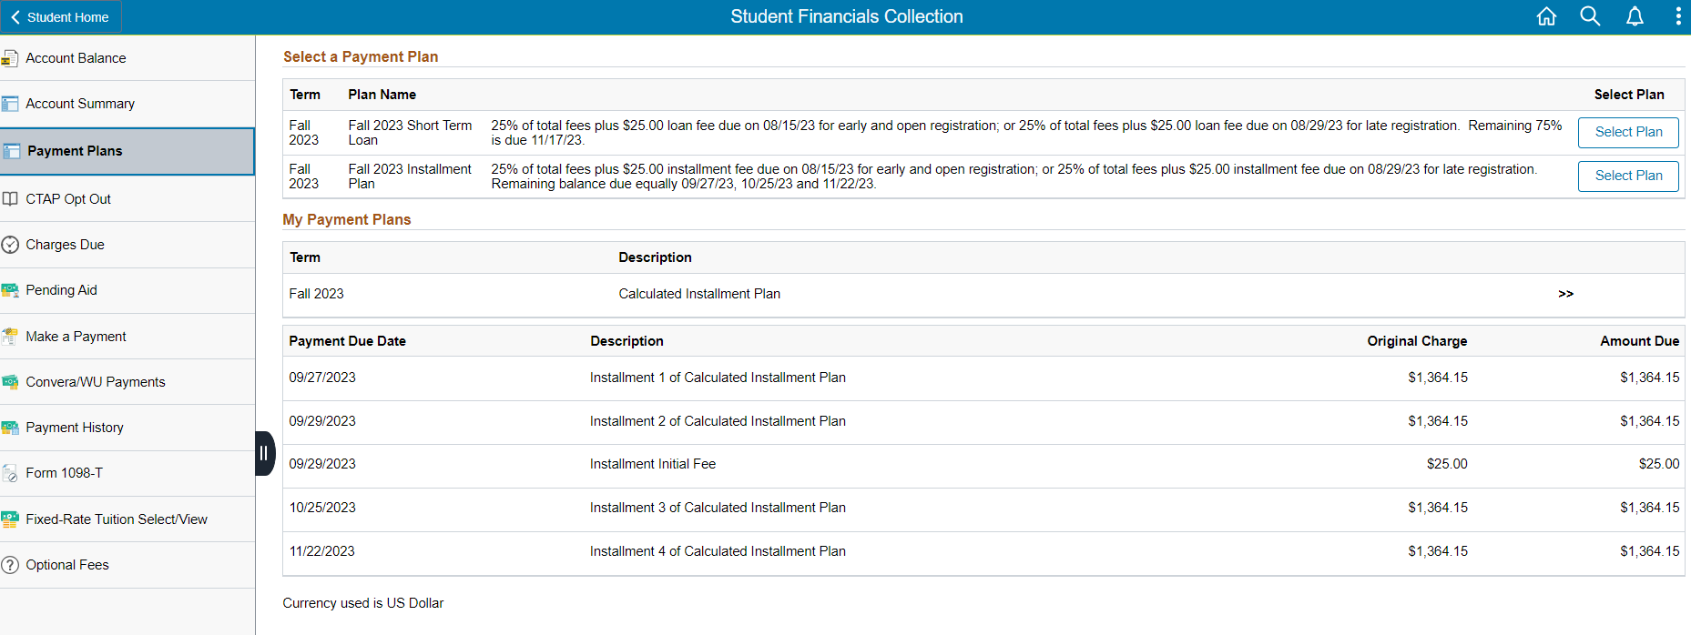

Step 9 Now you must make your first installment payment. Click Make a Payment.
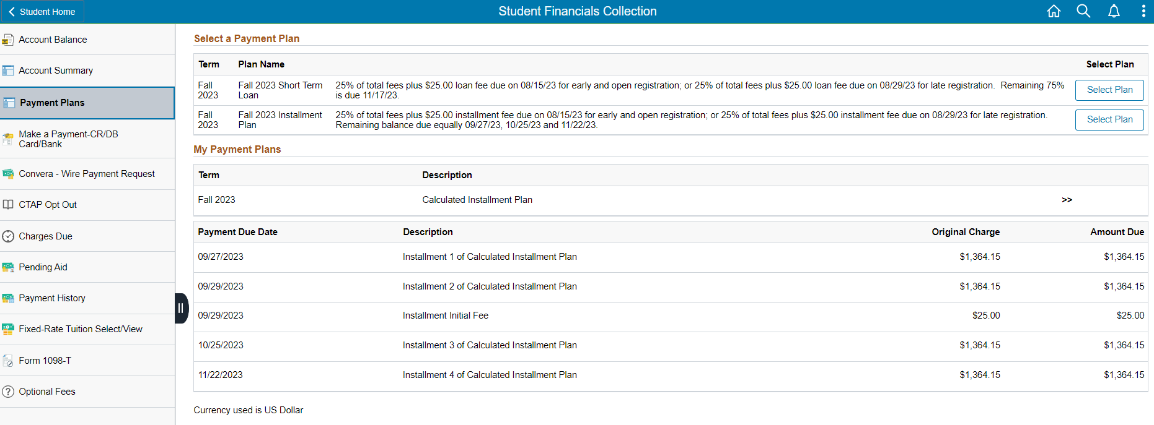

Step 10 Type in the payment amount (25% + $25 set up fee), pay by, accept terms & conditions, and click submit.
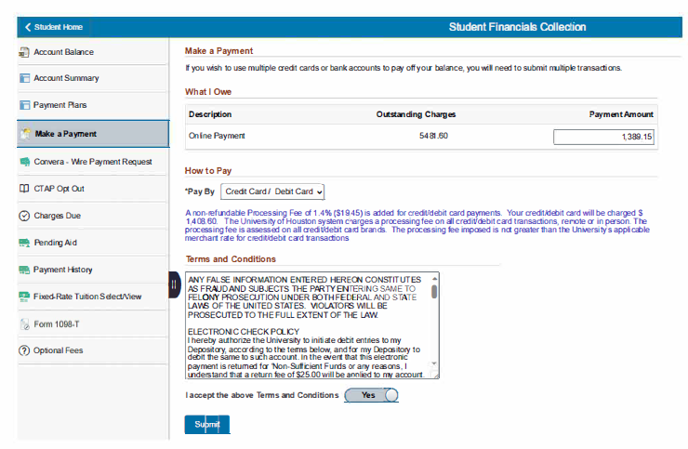

Step 11 Fill in all the required payment prompts and click, Continue.
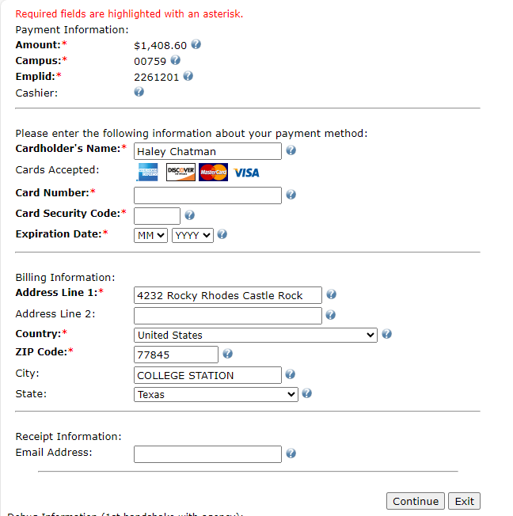

Step 12 Verify that all the information is correct and click, Confirm.
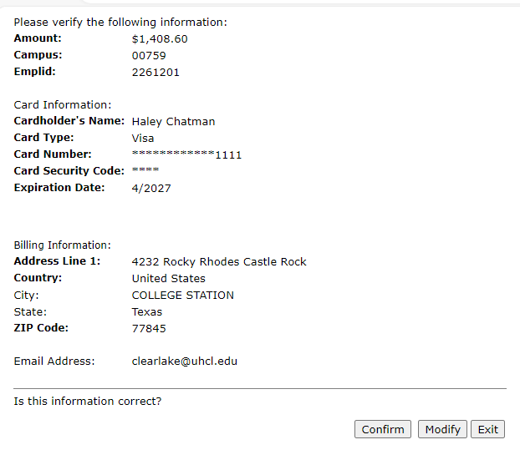
Once your payment has been accepted, you may return to your Home page.