Once fully admitted to the University of Houston-Clear Lake, follow the steps below to submit your bacterial meningitis vaccination documents to Med+Proctor. If you decline the vaccine due to reasons of conscience, including a religious belief, you must complete and submit an original notarized Texas Department of State Health Services (TDSHS) Vaccine Exemption Affidavit Form. This is the only acceptable documentation for this exemption. Exemption requests may take up to 3 weeks to be processed and mailed to you. Med+Proctor or UHCL must receive the original affidavit document within 90 days of being notarized (faxed or emailed copies are not acceptable). Medical exemptions must also be submitted through Med+Proctor.
Bacterial Meningitis Upload Instructions
The following steps are used to upload bacterial meningitis vaccination documents.
Steps | Descriptions
Log into E-Services through https://www.uhcl.edu/eservices/ or Go.UHCL.Edu.
Click on the E-Services tile.
In E-Services, click on the Academic Records tile.


On the left-hand menu, select Bacterial Meningitis Vaccine. Then click on Continue to Med Proctor Portal.
Note: Med Proctor Portal is only accessible for admitted students.
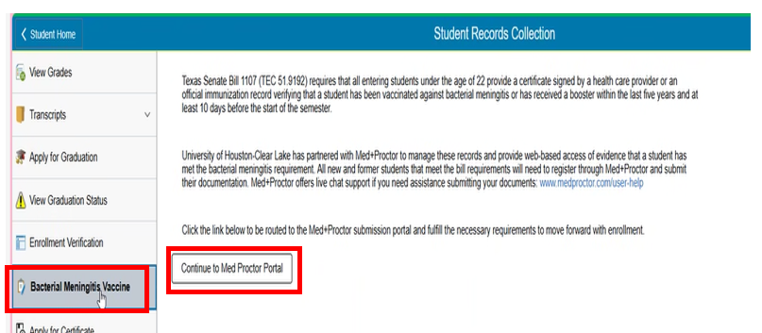

Verify your personal information, enter the required fields and click Continue.
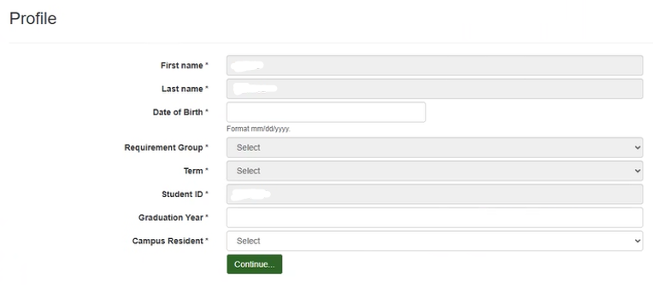

Review the User Agreement and enter your full name and click on Agree.
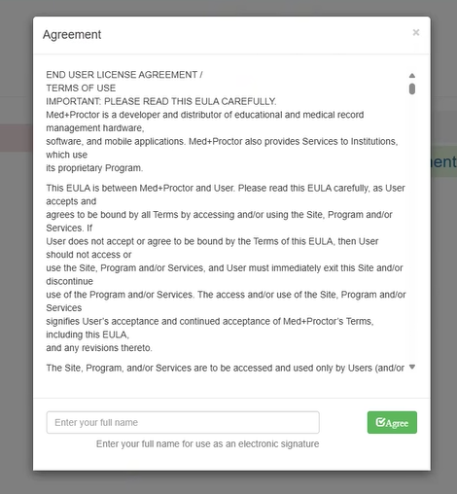

Med+Proctor offers an optional feature, MP Pro. This feature is not required to submit your vaccine record.
Click on “No, thank you” link at the bottom to submit the record.
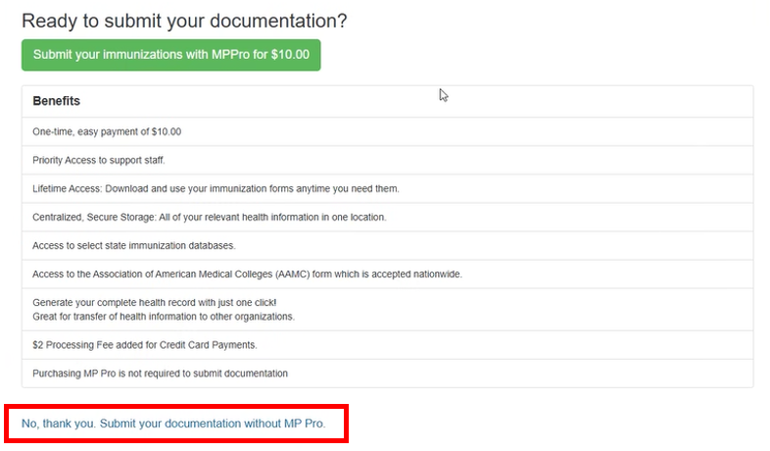

Select the document type and Choose Filesto upload your record.
Vaccine Record: Select Immunization Certificate
Exemption: Select Supporting Documentation

Click on Continue.
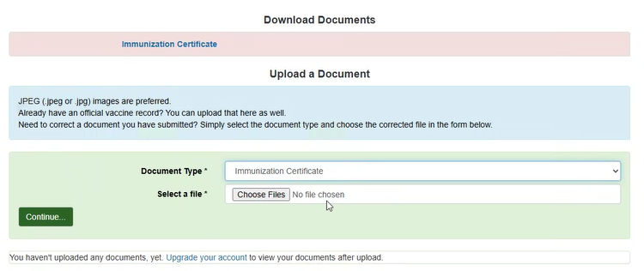

Med+Proctor offers an optional expedited review service. Select the option you prefer.
NOTE: Most records are reviewed within 24 hours.
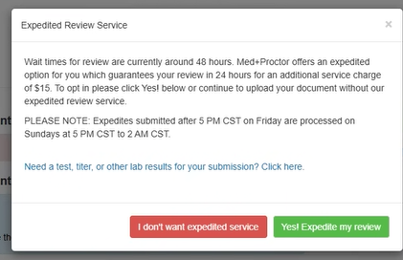

Standard record review usually takes 24-48 hours. You will receive an email with the status of your submission from Med+Proctor.

If your docmentation meets the requirements and is Approved, the bacterial meningitis hold will be automatically removed within 24 hours.

If your documentation does not meent requirements and is Rejected, the hold will remain, and you can resubmit the documentation through Med+Proctor.

