Instructions for a request for Additional Compensation
- Access request form here: Need to replace with production link
- Enter the signing authority’s information.
- Initiator’s information, this will be whomever is completing the form, after the initiator receives the link, they will be able to enter the details of the request.
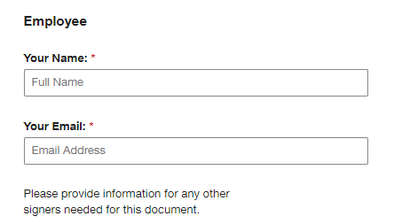

- Signatures for Unit Head, Division Vice President will follow.
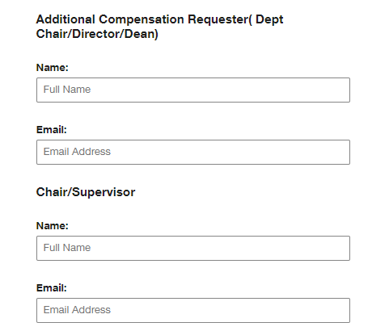
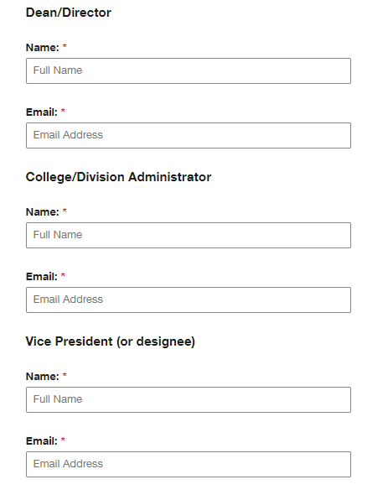
- Information for the Office of Human Resources will be auto populated.
- Initiate form by clicking on Begin Signing
- The form will be generated to the Initiator, in order to access the form, the Statement at the top of the screen will need to be acknowledged, and the Continue also at the top of the screen.
- The form is now available for data entry, to fill out the form;
- Enter the information of the employee who is receiving additional compensation.
- Describe the activities that entitle the employee to additional compensation.
- Please indicate the additional compensation the employee will receive.
- Section IV of the document should be completed by the unit in which the additional services are being performed.
- Depending on your role in the process, will depend on where your signature will be generated. Once all signatures have been collected, HR will be the final signer.
- When finished, click on Finished button at the bottom of the screen
Once finished, HR will process the form and reach out to sender if anything additional is needed.

