USA General Meeting Minutes
December 2020
- Meeting started
Esther Herrera Kicked off the first General Meeting by discussing the USA priorities for this fiscal year. A slide was presented with the priorities and have included the information below.
- UHCL Community
  - Present two LinkedIn Learning Course spotlights per month
    - Esther informed the general meeting that these opportunities could come directly from her as HR opportunities or from USA. These opportunities will have some value and allow you to continue to learn and grow.
  - Host a Virtual Learning Day
    - A lot of you have asked about professional development t days and the previous board had done a lot of work towards a great opportune ity, we are presented with new challenges and we will be reaching out to you about ideas and make sure it is beneficial to all.
  - UHCL Staff community social events
    - We will be working on social events. We are going to look at ways to
  - USA representative will attend and present at new employee orientation
- Financial Support
  - Organize 2 fundraising initiatives
    - We want to continue to do fundraising and award scholarships this year.
  - Award at least 2 USA Torres Scholarships
- Shared Governance
  - USA will connect with Faculty Senate Leadership once monthly and look for opportunities to collaborate.
  - USA will attend SGAZ meeting by USA president and or USA Vice President or another USA Board member
    - USA will collaborate with SGA to develop a campus-wide initiative or event for Spring 2021 semester
- Community Support
  - USA will participate in 1 person and 1 virtual community service event
    - Will have to follow protocols for COVID.
  - Local Business Promotion
  - Donations from local businesses to distribute at USA events

- USA Committee Reports
  - Fundraising Committee, Firoj Gurung
    - Firoj introduced himself and stated how excited he is to program and plan new fundraising activities. Nothing has been planned yet, since I just joined USA.
  - Professional Development, USA board
    - Focus will be to push out learning opportunities out to provide growth opportunities to each of you.
    - Stay tuned for virtual learning day.
  - Program Planning, USA board chair
    - Stay tuned for future developments, we plan to start developing socials and things soon.
  - Scholarship Committee, Dillon and Willie
    - Proposed Scholarship Timeline for Spring and Summer 2020 Semesters
As a result of not awarding scholarships last year due to COVID we are doing two separate scholarship timelines. Willie provided details of both timelines and an explanation to the USA members.
      - January 4, 2021
        - Call for scholarship applications open
      - January 29, 2021
        - Deadline for scholarship application submissions
      - February 1-5, 2021
        - Scholarship Application review
      - February 15, 2021
        - Announce Scholarship Winners
    - Proposed time line for Fall 2020 Semester
      - February 8, 2021
        - Call for scholarship applications open
      - March 5, 2021
        - Deadline for scholarships application submission
      - March 8-12, 2021*
        - Scholarship application review
      - March 31, 2021
        - Announce scholarship Winners
    - Esther added that this is exciting and wanted to let everyone know that Matt did catch it and if you have questions please put in chat box.
    - Willie introduced Dillon and Dillon said thank you.
  - Welcome & Outreach Committee, Veronica Gates
    - Veronica introdcued herself. We are planning to do more outreach via social media so keep an eye out. With new employee orientation, planning to attend and welcome new employees to USA. I would like to hear from people who have suggestions and appreciate feedback to make sure employee feels safe and has voice. My contact info is on screen it is gates@uhcl.edu. Esther, we do represent you all so anything you all see is value we are here for your feedback support and guidance. George Mattingly, served as Welcome and outreach cahir about two years ago. Suggested working with UCT to develop a staff list some have missed that in the past, develop listerv just for staff. At that time we reached out to UCT but don’t recall and there was issues with that etc., may want to follow-up on.
  - Treasurer Report
    - No expenditures since the new board took over.
    - Current account balances

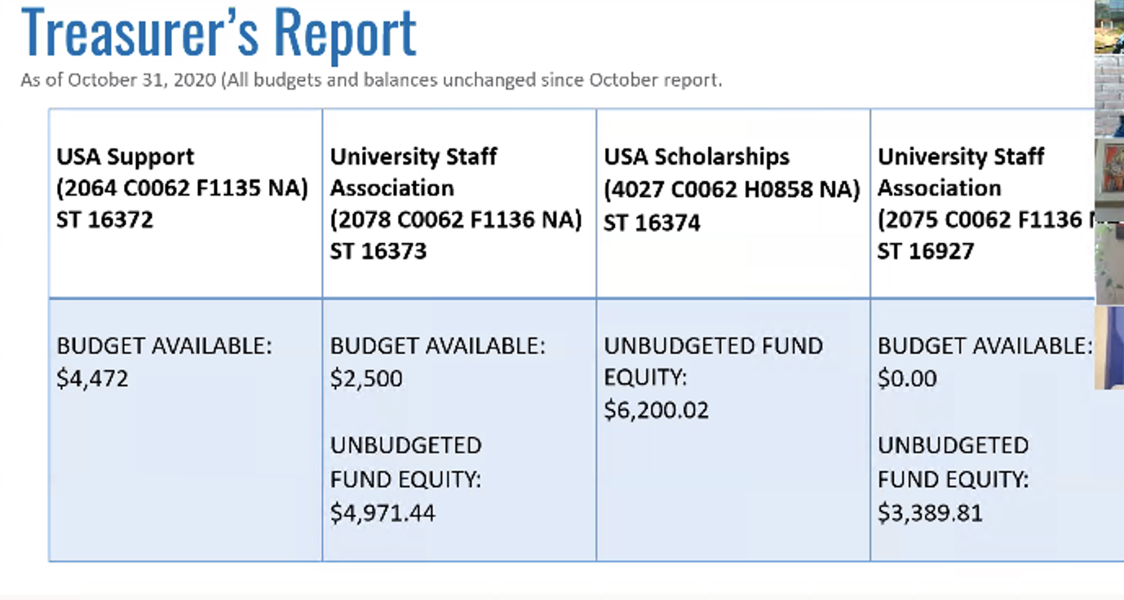
- Shared Governance Reports
  - Facilities & Support Services Committee (FSSC), Debra Ross and Kim Edwards
    - Esther did share on behalf of the committee.
    - Building updates Cont.
      - FMC is taking advantage of downtime to make necessary upgrades.
      - Classrooms are getting upgrades
      - Carpet being replaced in Delta Building
      - Elevator upgrades
    - UCT working to acquire software based on staff and faculty recommendations
    - Debra: FSSC had meetings in October and November and the big Bayou shuffle has been processed and moved. Two subcommittees are very active and parking will be more active soon.
  - Planning and Budgeting Committee, Leigh Ann Shelfer & LeeAnn Wheelbarger
    - Leigh Anne provided updates as listed below.
      - Planning for the UH-Clear Lake FY22 budget has begun. Can get info by going to: www.uhcl.edu/about/administrative-offices/budget/planning-budget-cycle
      - All budget initiatives must align with goals from the Strategic Plan, Impact 2025 and Beyond.
      - Timeline:
        - Feb. 15 – Budget Initiatives are due to unit heads and deans.
        - Mar. 8 – Budget initiatives are due to VPs.
        - End of April – PBC will consider list of initiatives advance ed by the VPs and cote on final list of recommendations to President Blake.
        - President Blake will make the final decision on initiatives to include in UH-Clear Lake’s budget and submit to UH system.
  - University Life, Cierra Davis
    - Cierra Davis introduced herself to the general meeting. I will be providing updates etc. and excited to be on USA. We did not have a meeting in December so nothing to report on this time.
- Pending business
  - Vacant Position:
    - Esther did discuss USA has a vacant position in treasurer and even though must other positions we as a USA board took those positions. In this case for Treasurer we really need to vote on this position. Tyler hall has stated he is interested in the role, he was the past-president. Tyler stated that this position is something he wants to learn and is of interest for him and as past-president wants to make sure that the board can use funds.
  - Staff Shout-Outs!
    - Esther explained this is a new addition to the USA meeting. We are looking for an opportunity to let others shine when they are going above and beyond what is expected.
    - This week shout out is for David Rachita, the Dean of Students. Esther shared a story about how David Rachita supported a senior student during a challenging time and how she was referred to the Dean of Students. Right off the bat he announced everything, let me rant, etc. Thank you to him I stayed on track to graduate this summer.
    - Esther we are excited to have people like David on our team since we are here for a greater purpose. Leading an ear to someone, we are proud Mr. Rachita for having people like you on our team and thankful for what you do to serve our students.
- Open Forum
  - Esther opened floor to the general meeting for any discussion.
  - Chief, Esther we appreciate all the efforts you put forth to create trainings for staff and appreciate all you do.
  - George Mattingly had a question; what type of USA have with administrative office and is it in the works to have more town halls. Esther responded this past year it has been a need and it is an option for us to have these meetings. Matthew stated that some identity based townhalls are on slate for spring and will give a variety of people to be checked in and allow everyone to voice thoughts, we also have a great relationship with. Dr. Elizabeth Beavers on faculty senate.
  - Debra: wants to thank board for getting word out and this meeting has a great amount of attendance even with current challenges.
  - Esther: Tiffany king is recording secretary for the new board. She’s helping us taking minutes.
  - Mark Denney: Thank you for allowing me to attend meeting, but wanted to take a moment to talk to group and we have been making rounds. We wanted to make sure to share with this group, the merit pay that was announced to be paused. Want to apologize first for the way things happened, we were focused on impact of external pressure and did not reach out to USA leadership before we sent out message campus wide, we want to say we are sorry. Second thing, merit pay was budgeted and approved has not been canceled but just postponed, I know this is not great being it has been four years without pay increases, must staff only received 1.5 percent adjustments. It is not can celled just delayed. We will revisit FY21 merit increases in spring and will. Go in place Sept. 1, 2021. Financial forum planning and anticipating merit increase each year, cannot guarantee the amount but will take place each year. We would double FY21 and FY22 in September effective date. Cannot guarantee rate FY21 have budgeted 3 percent and .5 percent equity adjustments etc. 2.5 percent for merit increases already budgeted in FY21. We have built reserves that allows us to be intentional and respond to challenges. I wanted to make sure the message is clear. Question: can this information be shared more publicly among campus, was shared with faculty per Mark. Financial Forum was recorded and Mark states it has been posted to website. Any additional questions after forum have responses on forum.
  - Questions on chat:
    - Flexible work schedule for staff.
    - Matthew: what do we take into consideration for employees in this matter and to advocate and be empathetic. Can we continue this flex scheduling and would it be possible when needed or requested moving forward?
    - Brad responded; This has been a challenge across the board, HR directors across the system. It does boil down to the supervisor and we will be in pandemic for a while and want works is based on what they see. A lot of challenges but people are making it work. We have some folks back on campus vast majority still at home and maybe the case for a while. The main thing is to stay safe and keep up operations as much as possible. We will let folks know.
    - George: Constituency are not the same, it is supervised driven. What if staff doesn’t feel comfortable coming in but yet supervisory wants them to.
    - Brad: If there is not a stay at home order etc., if it is a business need, we need to stay flexible and if need cannot be meet remotely then that’s what we go with. If person choices to not come in they need to take vacation or leave. Erika Deleon, HR, assistant director in office, over benefits. There are federal benefits set to end on Dec. 31 guidelines and reasons under these guidelines. Supervisors have called or staff, we have been working on this with both. Brad: case by case bases. Further discussion about supervisors and the ability to support staff.
    - Matthew: When we do make call more frequently to come back to make sure that staff has time to make accommodations.
    - Mark Denney: Under the pandemic, clear federal regulations and must from state and local government. Clear business need we have different definitions. This pandemic has demonstrated and has defined work as well as expectations and parameters. How do we continue these conversations and expect we will go to normal operations, but will be a good discussion for work life balance and continue some options for remote work?
    - Erika: several things have been mentioned about working from home. It is convenient and stressful and hard to divide personal and work life. Try to cover everything, Kristen is benefits coordinator about EAP and good Linkedin resources, please take advantage of these. We can send out additional email if need be. A lot going on but there are resources out there.
    - Esther: This is new for all of us, there is a lot of learning to be done. Thanks for being open and sharing, this is how we can get you answers.
    - Firoj: Thank you for Erika and Brad.
    - Esther: Thank you for sharing.
  - Meeting adjourned.

