Blood pressure

Give item

Eyes (otoscope/fundoscope)

Mouth

Ears

Eyes (pen light)

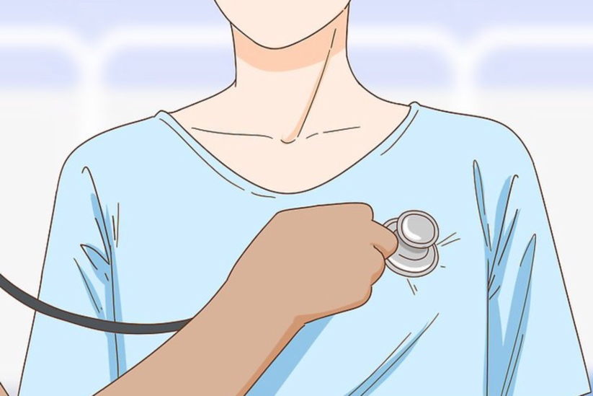

Abdomen (palpitations)

Abdomen (auditory)

Heart

Lungs (back)

Lungs (chest)

Nose