**Completing DocuSign form**

**Summary for Purchases Exceeding $100,000**

**($100K - $300K template)**

**Accessing Template**

**Click** on this link to access [DocuSign](https://app.docusign.com/).

**Click** on **Templates** tab on top



Then **Click** on the **Procurement** folder under Shared Folders

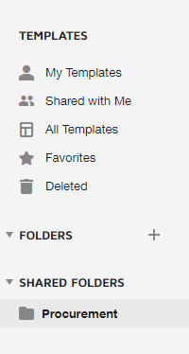

Select  for UHC **Summary of purchases exceeding $100K and within $300K**

**Roles**

**Initiator**

Initiator can be from Procurement or within the department.

Upon opening the Initiator will see the screen below. The initiator will enter in a name for each recipient. Then hit send at the bottom right of screen.

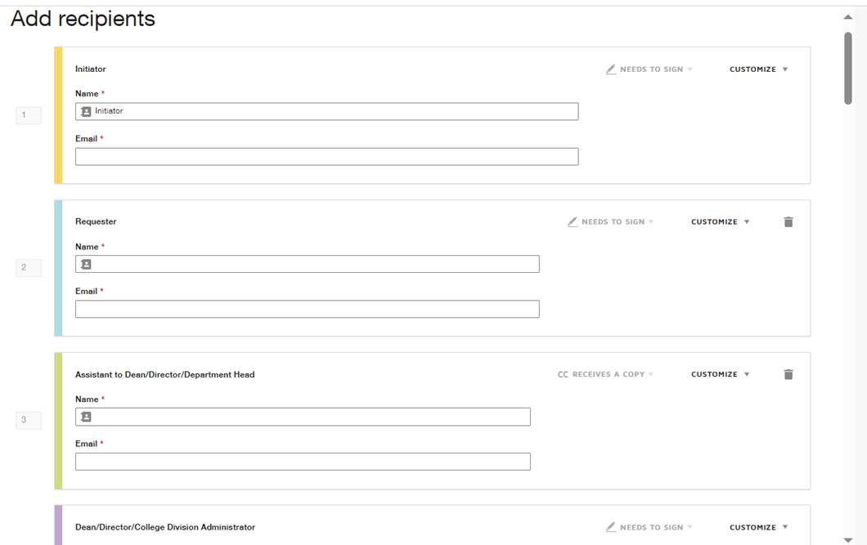

A box will pop up asking the Initiator if they would like to sign now or sign later. If signing now the initiator will be taken to complete the form.

An email is also sent to the Initiator. If initiator clicked Sign Later on the pop up, to access the form Click review documents on the received email.

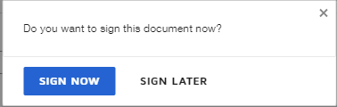

The Initiator will be redirected from either the pop up or from the email that was sent to complete the form. Agree to signing digitally by hitting Continue.

Complete the following on the form:

* + Requisition#
  + Department Name
  + Describe
  + Amounts
  + Cost Center
  + Vendor Name

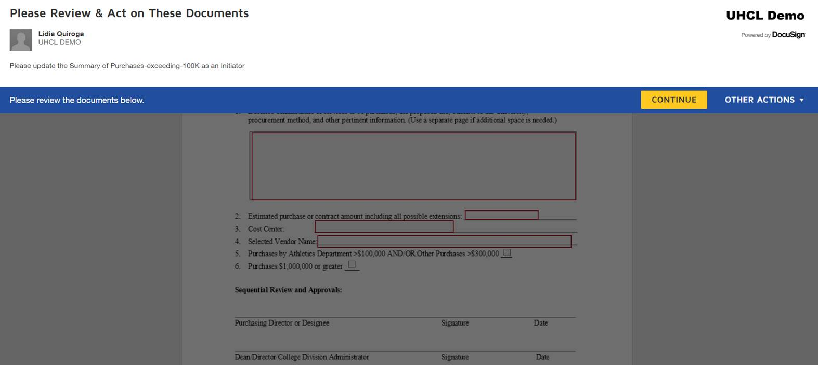

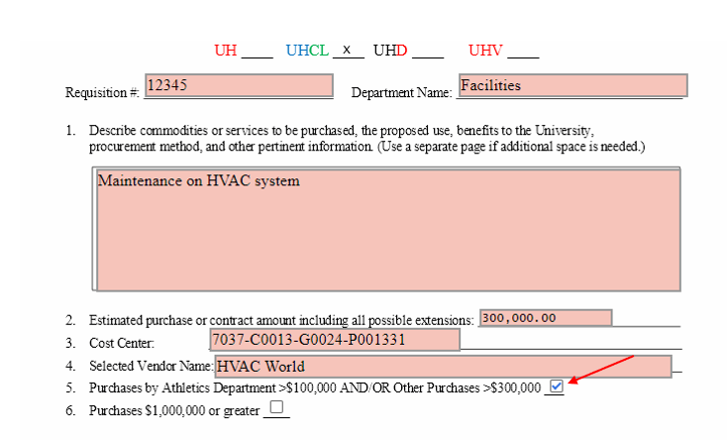

At the bottom of the form there will be a paperclip icon. Click on the icon to upload documentation pertaining to the contract.



Once the form is complete and uploads have been added, click finish on the bottom right. An email will be sent to the next recipient.

**Optional roles**

If a role is optional and will not be included, click on the trash can icon to right of the Recipient title and the role will be removed. If the role does not have a trash can icon, the role is required.

Requestor - This role is optional. This role is to be included when the Initiator is from within the department, but forwarding to someone else to complete the form or upload documentation or from outside the department. This role will be allowed to update the form and upload any documentation pertaining to the contract. This is not a signatory role.

Assistant to Dean and Assistant to the VP - These roles are optional. Each role will only be able to view the DocuSign form. This is not a signatory role.

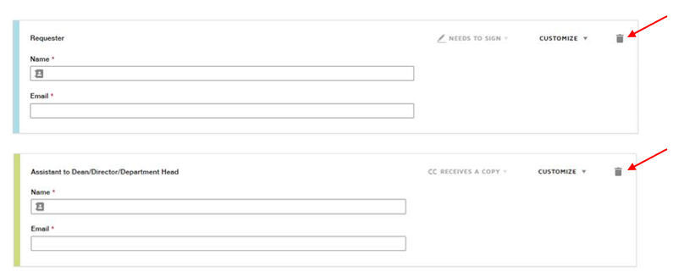

**Requestor**

The Requestor will receive an email stating there is a document to review and sign.

Click the Review Documents button to be taken to DocuSign.

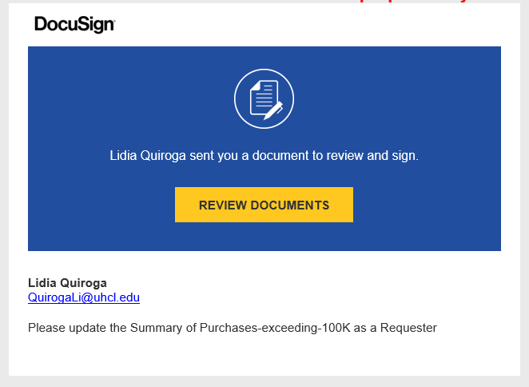

The Requestor will need to add any additional details to the form and/or upload any additional documentation. Once completed, click Finish.

An email will be sent to either the Assistant to the Dean/Director/Department Head or straight to the Dean/Director/Department Head if the Assistant was not included.

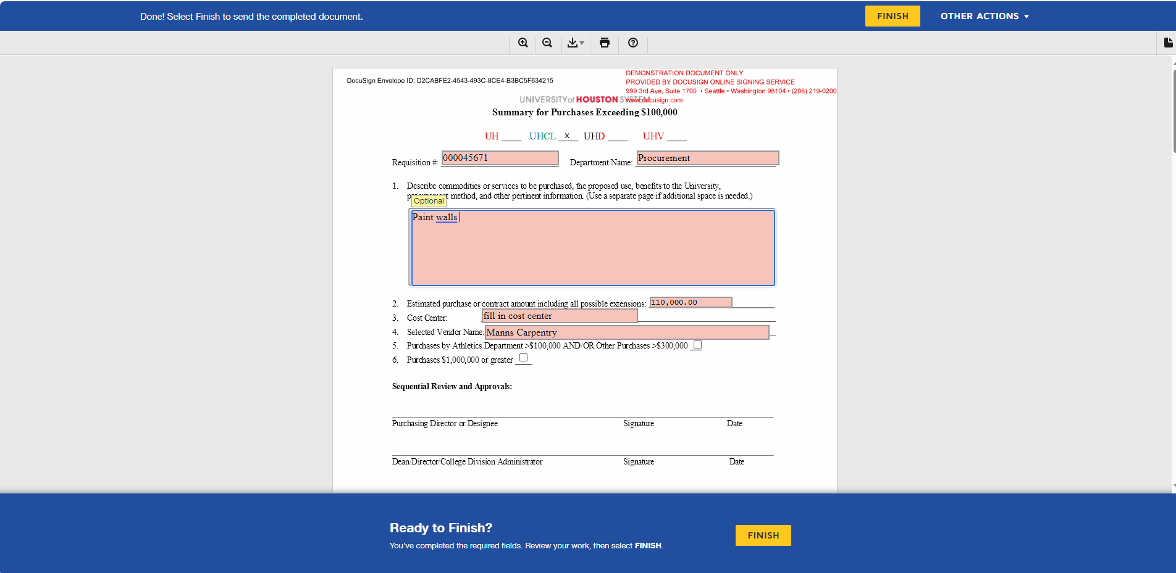

**Dean/Director/Department Head and Vice President**

An email notification will be received and indicate that the there is a DocuSign form that needs to be reviewed and completed. Enter the form by clicking Review Documents.

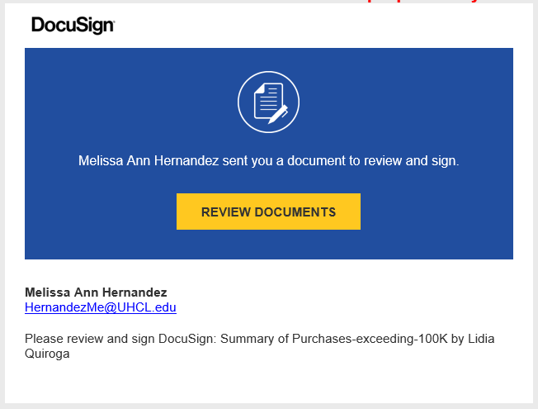

The following header will be seen asking to review the documents below. Click on the Continue box.



Review the form and upload additional documentation if needed.

Click Start at the top left of the form. The form will advance to the location that requires signature.

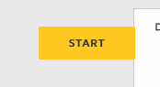

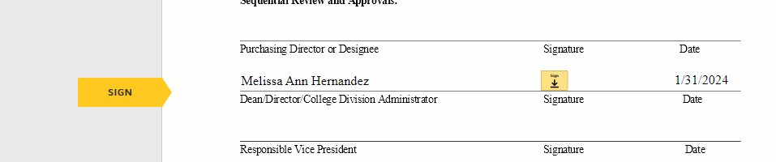

Click on the Sign icon to sign the document.

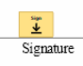

Once signed, click on Finish.

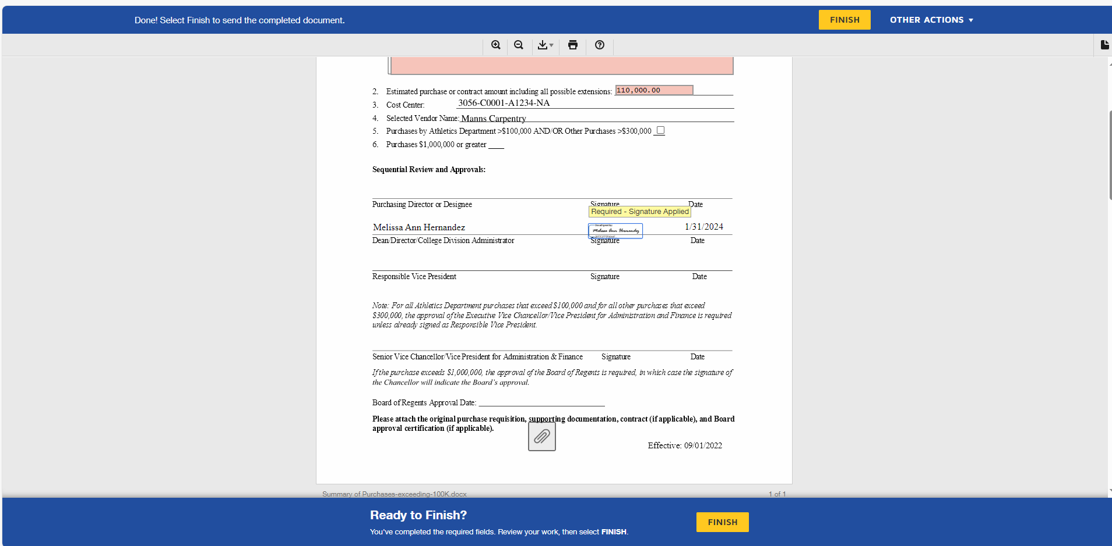

The form will be forwarded to the next person. When the form has been fully signed all roles will receive a copy of the signed form.

**Declining to sign**

Should the recipient decide not to sign the document, click other actions drop down and select decline to sign.

Choosing decline to sign will pop up a message cautioning that clicking continue will void the document.

Alternatively, the recipient can choose to cancel and go back to other actions and choose to finish later or Assign to Someone Else.

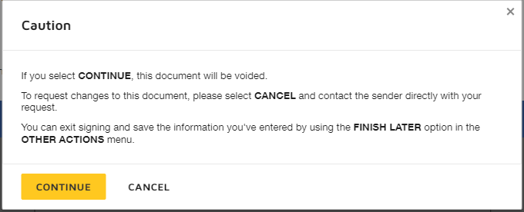

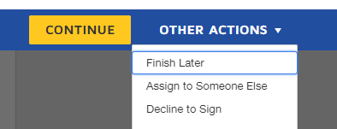

**Workflow**

The workflow of the document can be viewed within DocuSign. Under Envelopes select Inbox and select Manage at the top

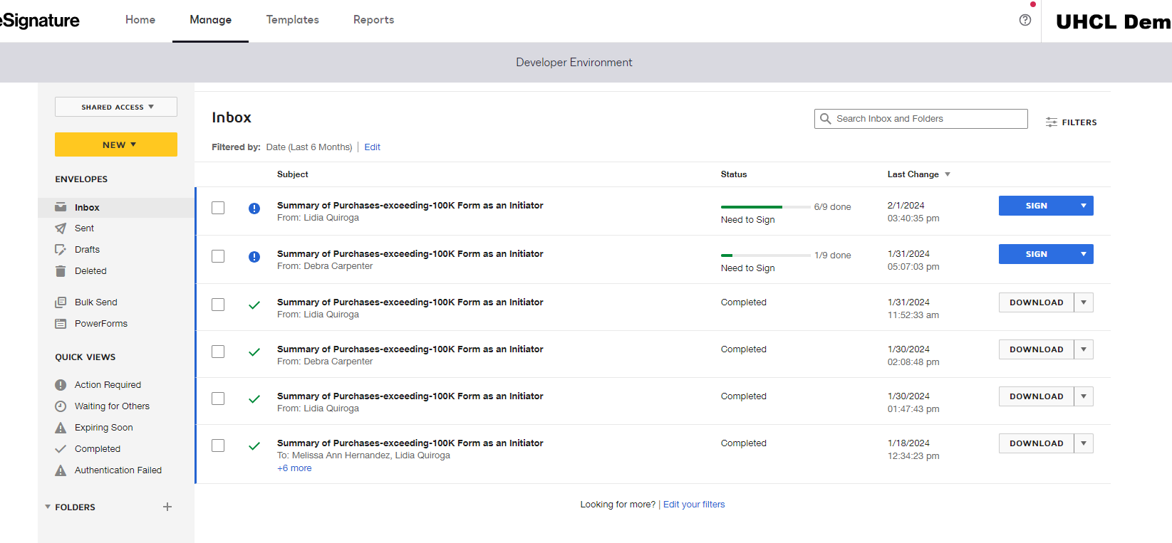

Select the document and a list of recipients will show. A green check mark will appear next to the recipient’s name if that recipient has already signed. No check mark will appear next to the recipient’s name if they have not signed.

