Instructions for submitting a Revenue Contract Request
- Access request form here: Revenue Contract Request above 50k Form

Enter the requested information for the form.
College/Division Administrator’s Information
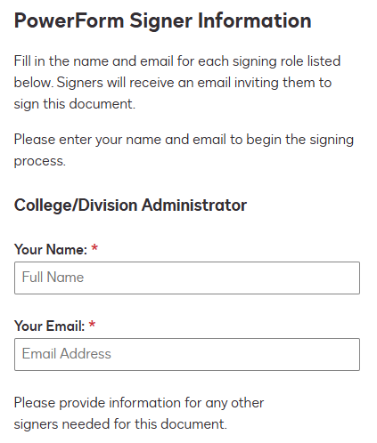

- Assistant VP/Dean, CFO/Designee Information will follow.
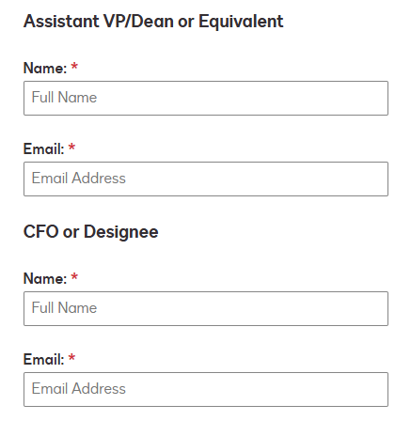

- Initiate form by clicking on Begin Signing
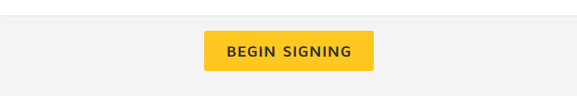

- The form will be generated for the College/Division Administrator. To access it, acknowledge the statement at the top of the screen and select 'Continue'.
- The form is now available for data entry. To complete it, follow the steps below:
- Fill out the General Information of the Contract:
  - Choose the appropriate Contract Amount
  - Provide the Name of the College or Division that is responsible
  - Attach Contract Document
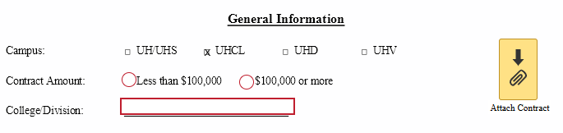

- Sign Agreement
- Fill out the Summary of Contract Terms:
  - Enter the Vendor Name for which the contract needs to be created.
  - Provide a detailed contract description and specify the purpose of the contract.
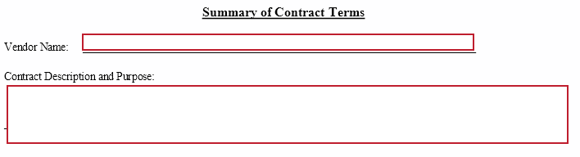
  - Please provide the start and end dates of the initial contract term (required).
  - Include possible renewal options with start and end dates (optional).
  - Provide the initial contract amount (required) and the revised amount (optional).
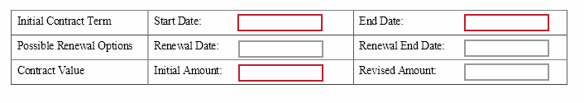
When finished, click on ‘Finish’ button at the bottom of the screen

Once finished, the form will be routed to the individuals identified at the beginning of the form creation process.

