PEROXIDIZER –

Peroxide Forming (PEC’s)
Potentially Explosive Chemicals
Examples: Ethyl Ether, Diethyl Ether, Tetrahydrofuran, Acetaldehyde, Benzyl Alcohol, 2-Butanol, Cumene, Furan
Containers must be labeled with Testing every 12 months
(if not, it will require High Hazard bomb squad stabilization)

POTENTIALLY EXPLOSIVE!
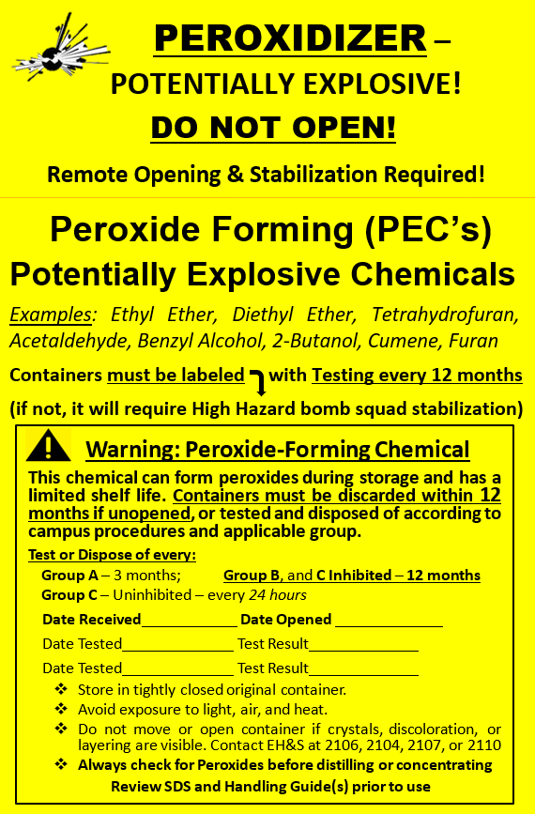

DO NOT OPEN!
Remote Opening & Stabilization Required!

Warning: Peroxide-Forming Chemical
This chemical can form peroxides during storage and has a limited shelf life. Containers must be discarded within 12 months if unopened, or tested and disposed of according to campus procedures and applicable group.
Test or Dispose of every:
Group A – 3 months; Group B, and C Inhibited – 12 months
Group C – Uninhibited – every 24 hours
Date Received ___________ Date Opened _____________
Date Tested_____________ Test Result_____________.
Date Tested_____________ Test Result_____________.
- Store in tightly closed original container.
- Avoid exposure to light, air, and heat.
- Do not move or open container if crystals, discoloration, or layering are visible. Contact EH&S at 2106, 2104, 2107, or 2110
- Always check for Peroxides before distilling or concentrating
Review SDS and Handling Guide(s) prior to use

