APPENDIX 11: STANDARD OPERATING PROCEDURES TEMPLATE

(Insert name of chemical/process/experiment here)
Standard Operating Procedure Rev Date: 08/01/2024

This standard operating procedure (SOP) outlines required methods to be used by researchers during this outlined experiment or process. These practices and procedures are intended to provide a safe working environment, promote a culture of forward-thinking risk mitigation, and to promote compliance with federal, state, and local regulations.

APPLICABILITY

This SOP is for processes, experiments, or manipulations that pose moderate risks and that call for protective steps beyond those dictated by accepted laboratory standards. They are intended to limit the potential for injury, equipment damage, or environmental impact

This SOP is not applicable to….

RESPONSIBILITIES (Add to list as appropriate)

PI/Supervisor:
- Implement the guidance outlined in this document within departmental/institute operations.
- Provide training to laboratory personnel regarding the specific hazards involved in working with (enter name of chemical/process/experiment here) to include work area decontamination, and emergency procedures prior to conducting any work.
- Provide laboratory personnel with a copy of this SOP and a copy of the SDS(s) provided by the manufacturer.
- Ensure that laboratory personnel have completed appropriate laboratory safety training and/or refresher training as required.
- Ensure all personnel are trained on the proper use/operation of any equipment used during the experiment or process.
- Require the use of proper lab attire (lab coats, gloves, eye protection, and other PPE as required).
Researchers (Graduate Students/Postdocs/Research Staff)
- Implement and follow minimum working protection found in this document.
- Complete appropriate laboratory safety training.
- Wear appropriate personal protective equipment that includes but may not be limited to a lab coat, gloves and eye protection in the laboratory.
- Report all near misses, incidents, and unsafe acts or conditions to the principal investigator and EHS. Any injuries must also be reported to Human Resources. Reporting forms may be found at the following link: https://www.uhcl.edu/about/administrative-offices/environmental-health-safety/forms.
Undergraduate Students
- Follow minimum working protection found in this document.
- Complete appropriate laboratory safety training.
- Wear appropriate personal protective equipment that includes but may not be limited to a lab coat, gloves and eye protection in the laboratory.

PROCEDURE

Fill in all highlighted areas with appropriate information

INSERT TITLE OF EXPERIMENT OR PROCESS
This is where you can type out a description of the experiment or process you will perform. Just give an overall view. You will be walking through the experiment or process step by step below.
Preparer: Insert Name |  |  |  | Location: Bayou/STEM/Arbor
Authorized Personnel with Contact Information
Position |  |  |  | Name |  |  |  | Number/Email
Principle Investigator/Supervisor |  |  |  | Insert Name |  |  |  | 555-555-5555/someone@uhcl.edu
Student/Technician/Operator |  |  |  | Insert Name |  |  |  | 555-555-5555/someone@uhcl.edu
Others to be notified (e.g., other workers in the same laboratory, or other members of the research group) |  |  |  | Insert Name |  |  |  | 555-555-5555/someone@uhcl.edu
HAZARDS, CONTROLS, CONDITIONS, & REQUIREMENTS
Potential Hazards
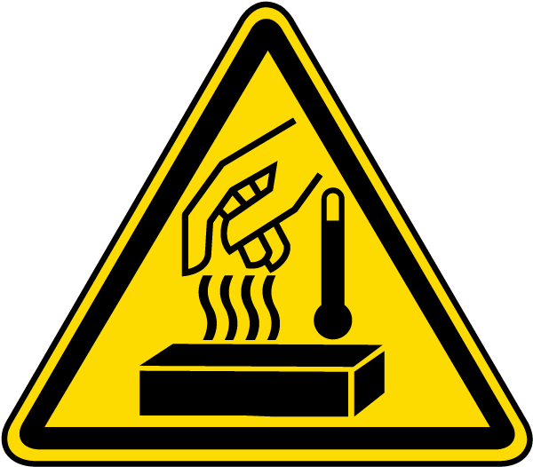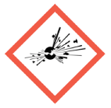
Copy and paste relevant pictograms. (Examples in attachment 1)
Planned Chemicals Involved |  |  |  | Hazards
Insert chemical name(s) |  |  |  | List relevant hazards for chemical. (Examples in attachment 1)
Planned Equipment Involved |  |  |  | Hazards
Insert equipment name |  |  |  | List relevant hazards for equipment. (Examples in attachment 1)
Hazard Controls
Engineering |  |  |  |  |  |  | Work Practice
Examples include:  - Fume hood or glove box  - Special ventilation  - HEPA-filtered vacuum lines  - Non-reactive containers  - Pressure relief devices  - Temperature control  - Pressure control  - Bench paper, pads, plastic-backed paper  - Special signage  - Safe sharp devices  - Guards  - Connect to ground |  |  |  |  |  |  | Examples include:  - Designated areas  - Procedures for requesting emergency assistance  - Emergency phone numbers  - Locations of fire alarms, fire extinguishers, fire blankets, eye washes, showers, etc.  - Emergency responders  - Workers on shifts  - Training on all experimental techniques and experiments  - Restricting access; locks  - Housekeeping  - Lockout/tagout a procedure plan  - After-hour procedures  - Preventive maintenance
Required PPE


Copy and paste relevant pictograms with descriptions as needed. (Examples in attachment 2)
Experiment Operational Ranges and Conditions
Pressure: |  | Insert info | Temperature: |  |  | Insert info |  |  | Volume: | Insert info
Flammability Range: |  | Insert info | Other: |  | Insert info as necessary
Special Handling & Storage Requirements
Insert handling and storage information here
Spill & Incident Procedure
Insert spill and incident procedure here
Waste Handling & Disposal
Most spent, unused, and expired chemicals/materials are considered hazardous wastes which must be properly disposed of. DO NOT dispose of chemical wastes by pouring them down a sink or drain, or discarding them in the regular trash containers. All hazardous and non-hazardous wastes must be properly packaged in compatible containers and removed to the designated waste storage area for the affected lab (Room AA for Bayou Building labs, Room 3125 for STEM Building labs). Contact EHS at 281-283-2104 or 281-283-2106 for any assistance required.
Training Requirements
- Complete EHS online Laboratory Safety training is available online. Contact EHS at 281-283-2106 for access.
- Review SOP with knowledgeable person.
- Complete training on operation of specialized equipment prior to use (e.g., ultracentrifuge, hydrogenation apparatus).
- Other EHS training requirements (e.g., Nanoparticle Safety, Radiation Safety, Hazardous Waste Management, etc.) as appropriate.
PROCEDURE
Step # | Directions
1 | Insert procedural steps for experiment or process. Add to table as needed.
2
3
4
5
6
7
VERIFICATION & REVIEW
Current Date |  |  |  |  |  | Date of SOP Expiration
00/00/0000 |  |  |  |  |  | 00/00/0000
PI Name |  |  |  |  |  | PI Signature
Insert Name
Safety Reviewer Name |  |  |  |  |  | Safety Reviewer Signature
Insert Name
LIST OF REFERENCES
Include Safety Data Sheets, Globally Harmonized System, any outside personnel consulted in preparation of document, peer reviewers, etc.

SOP Training Certification

I have read and understand the above SOP. I have taken all appropriate EHS training. I have received prior approval from my supervisor to perform this procedure. I agree to contact my supervisor if I plan to modify this procedure.

Name | Signature | Uhcl Employee ID | Date

Principal Investigator | Revision Date

PROCEDURE MODIFICATIONS/REVISIONS
Current Date | Modifications or Revisions | Name
00/00/0000 | Insert summary of changes made | Insert name of person making and/or approving changes
00/00/0000 | Original document | Insert name of person making initial procedure

Attachment 1 -- Remove after use
Pictograms and Hazards
Chemical Hazards
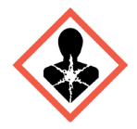 | - Carcinogen  - Mutagenicity  - Reproductive Toxicity | - Respiratory Sensitizer  - Target Organ Toxicity  - Aspiration Toxicity
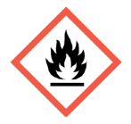 | - Flammables  - Pyrophorics  - Self-Heating | - Emits Flammable Gas  - Self-Reactives  - Organic Peroxides
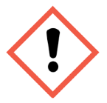 | - Irritant (skin and eye)  - Skin Sensitizer  - Acute Toxicity (harmful) | - Narcotic Effects  - Respiratory Tract Irritant
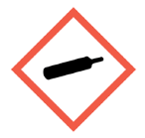 | - Gases Under Pressure
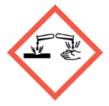 | - Skin Corrosion/Burns  - Eye Damage  - Corrosive to Metals
- Explosives
- Self-Reactives
- Organic Peroxides
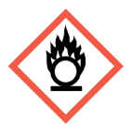 | - Oxidizers
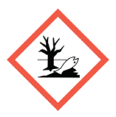 | - Aquatic Toxicity
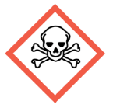 | - Acute Toxicity (fatal or toxic)
Physical Hazards
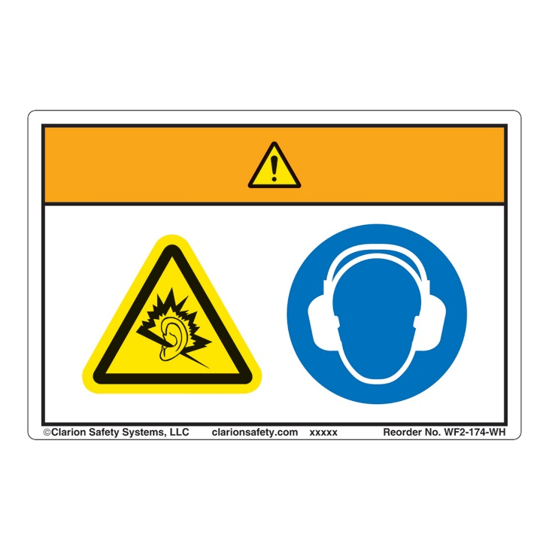 | - Noise
 | - Moving Parts
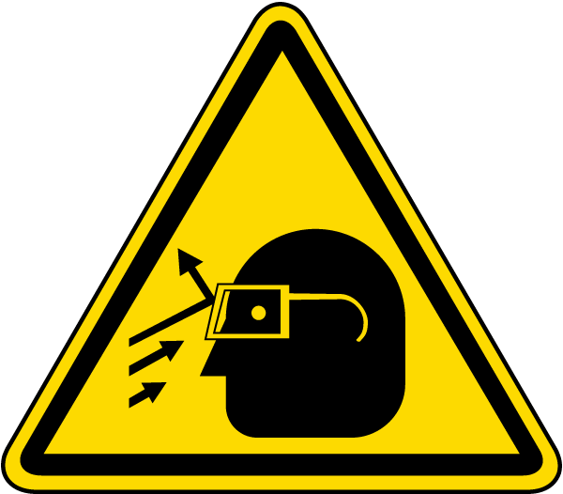 | - Projectiles
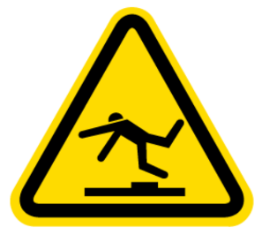 | - Slip/Fall
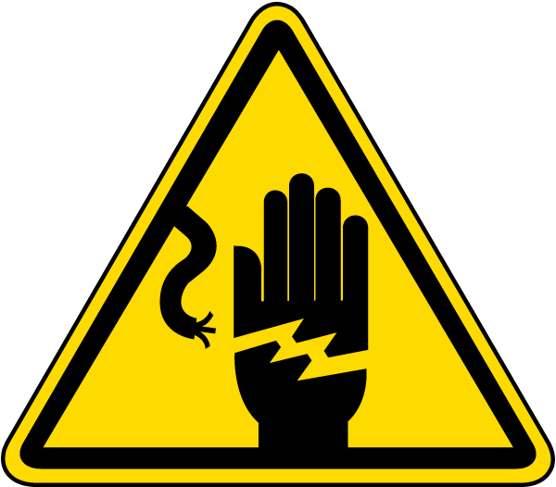 | - Electrical
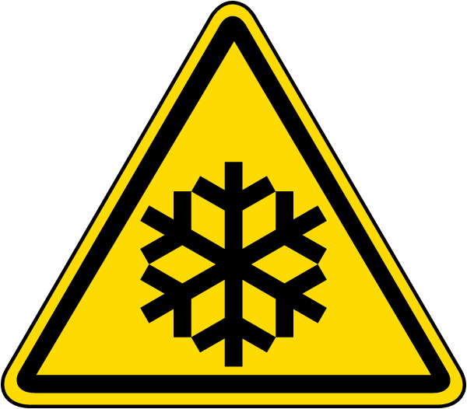 | - Low Temperature
- Hot Substance
- Hot Surface
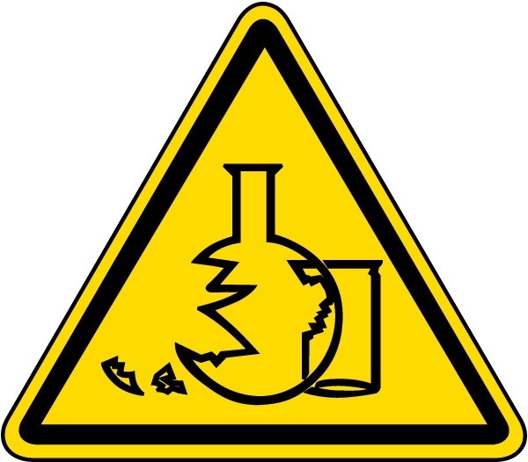 | - Glass Hazard
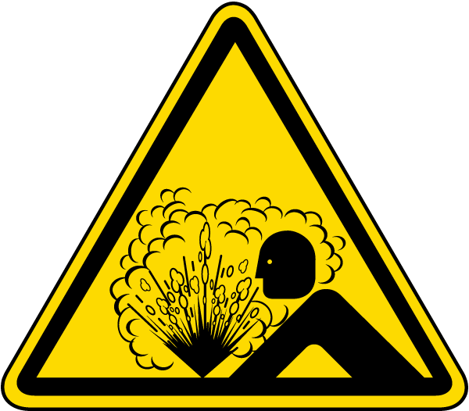 | - Pressure Release

Attachment 2 – Remove after use
Pictograms and Descriptions
Personal Protective Equipment
 | Hard Hat
Eye Protection
- Safety Glasses
- Safety Goggles

 | Face Shield
 | Hearing Protection  - Ear Plugs  - Ear Muffs  - Canal Caps
 | Filtering Facepiece Respirator  - N/R/P95  - N/R/P99  - N/R/P100
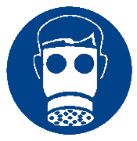 | Tight Fitting Respirator  - Half Face  - Full Face
 | Welding Hood
 | High Visibility Clothing
 | Lab Coat
 | Additional Apron  - Acid splash, liquid resistant  - Dust, grease
 | Clothing protection  - Long sleeve shirt and pants  - Leather  - Fire Resistant  - Chemical Resistant
 | Gloves  - Vinyl  - Nitrile  - Cotton  - Cut Resistant | - Heat Protective  - Rubber  - Cold Protective  - Anti-vibration
 | Foot Protection  - Closed Toe  - Slip Resistant  - Conductive  - Safety Toe

