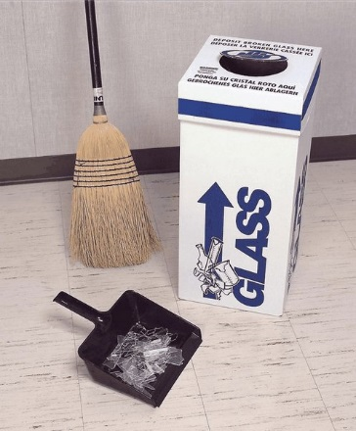
Glass is a hazard for our janitorial staff when placed in the regular trash can as it will easily puncture trash bags. All glass waste must go in the designated box provided in the lab.
Only Glass In The Glass Box

Keep it Clean - All Glass going into the box must be clean – if it is contaminated it must be disposed of as hazardous waste.
No chemical residue, NO Liquids
Do not put pipettes into glass boxes: pipettes have their own waste box (chemical labs) or receptacle (biotech for autoclave disinfection).
Do not overfill the glass boxes so that the bag inside can be tied and the box can be taped shut. Glass must fit inside the box, below the lid.
Do not put regular trash into the glass boxes.
CLEAN, BROKEN GLASS ONLY
NO CHEMICAL RESIDUE
NO REGULAR TRASH
NO LIQUIDS

