- Complete the Request for Item Type Action Form to create or modify an item type.

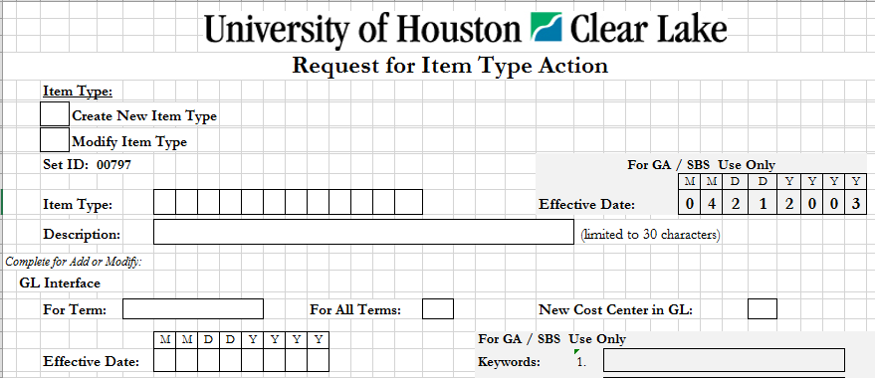

- Check the box to either create or modify an Item Type.
- Enter the Item Type number if the Item Type is to be modified. General Accounting will assign the new Item Type Number for Item Type creates.
- Enter the Description or Name of the Item Type (limited to 30 characters).
- Select the term from the drop down box applicable to the new or modified Item Type. Select “For All Terms” if prior terms are to be modified as of the effective date.
- Select “Yes” from the drop down box if the cost center for this Item Type is a new cost center in GL. If the cost center is a new cost center, this Item Type Action Form must be attached to the Cost Center Action Form.
- Enter the date the item type is to be effective.
- The gray area effective date is for General Accounting / Student Business Services office use only.

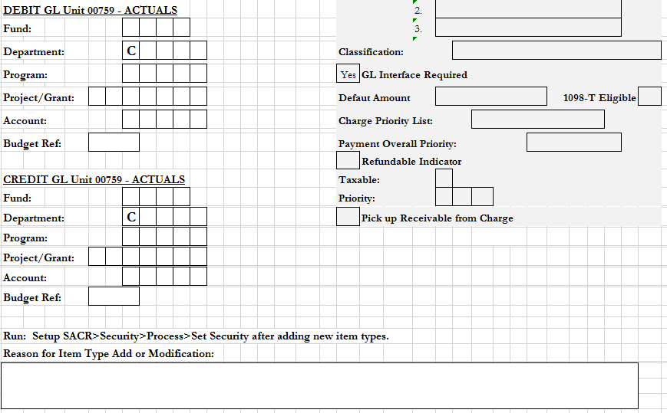

- Enter the Debit and Credit Fund, Department, Program, Project/Grant, Account, and Budget Reference for the item type to feed to GL.
- Give a reason for this Item Type creation or modification.

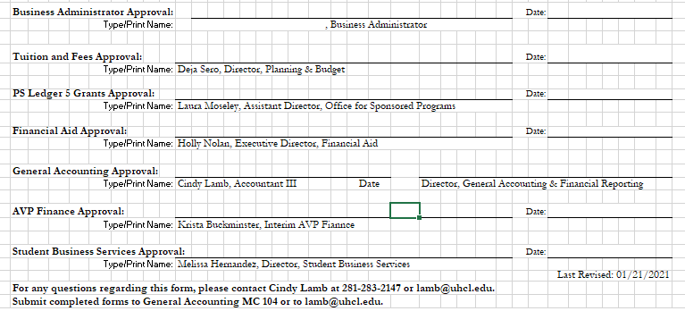

- The following types of approval signatures are required in the listed scenarios above:
Business Administrator Approval | Required when creating or modifying any Item Type.
Tuition and Fees Approval | Required when creating or modifying an Item Type related to Tuition and Fees.
PS Ledger 5 Grants Approval | Required when creating or modifying an Item Type related to Ledger 5 Grants.
Financial Aid Approval | Required when creating or modifying an Item Type related to scholarships or waivers.
General Accounting Approval | Required when creating or modifying any Item Type.
AVP Finance Approval | Required when creating or modifying any Item Type.
Student Business Services Approval | Required when creating or modifying any Item Type.

- For questions on these instructions, please contact Cindy Lamb at 281-283-2147 or at lamb@uhcl.edu. Submit completed forms to General Accounting MC 104 or to lamb@uhcl.edu.

